Lancashire Skills and Employment Board

Private and Confidential: No

Wednesday 27th July 2016

Up-date from the Lancashire Skills Hub
Report Author: Dr Michele Lawty-Jones, Director of the Lancashire Skills & Employment Hub, michele.lawty-jones@lancashire.gov.uk & Lisa Moizer, Co-ordinator of the Lancashire Skills & Employment Hub lisa.moizer@lancashire.gov.uk

Executive Summary

This paper provides an overview of the Lancashire Skills Hub activity since the last board meeting.
Recommendation
The Board is asked to note the up-date.

1. Careers Education, Information, Advice and Guidance (CEIAG)

  - The LEP was successful in its bid to the Careers and Enterprise Company for an 'Enterprise Adviser Network'. The pilot project, which launched in January in Blackburn with Darwen and Burnley, aims to stimulate engagement between businesses and industry and schools to inspire young people and provide CEIAG. Essentially the project involves a funded Enterprise Coordinator, working with a network of Enterprise Advisers (business volunteers) and a network of schools to develop employer engagement strategies and plans. Our Enterprise Coordinator, Kay Vaughan - employed by Inspira who oversee the day-to-day delivery, will provide a presentation at the meeting about the pilot and early successes.

1.2 Formal confirmation of grant funding for the next two academic years has now been received and match funding has been secured locally through Lancashire County Council. This will enable the network to be expanded to 60 schools across Lancashire from September 2016, and to 120 in September 2017. Further details will be provided in the presentation at the meeting.
1.3 The JCP Pathfinder with schools is now fully operational. The pathfinder is also focused in Burnley and Blackburn with Darwen, to aid coordination and it is intended that it will also extend across Lancashire next academic year in parallel with the Enterprise Adviser Network.

1.4 A breakfast event, is being planned with partners to celebrate the early successes of the Enterprise Adviser Network, collaborative working and to formally launch the JCP Pathfinder and the roll out of the Enterprise Adviser Network in Lancashire. It will be hosted by Edwin Booth and the Chief Executive of the Careers and Enterprise Company, Claudia Harris. The event will be held on the 30th September at the Dunkenhalgh Hotel, please note the date in your diaries.

1.5 The Careers and Enterprise Company are also launching a procurement exercise to contract mentoring providers across the Country to help establish a network of business mentors who will mentor young people in Years 8 and 9 who are at risk of disengaging. This is complementary to the ESF activity recently tendered, and is welcomed as an earlier intervention to support young people to reengage pre-GCSE. The Lancashire Skills and Employment Hub will be involved in the evaluation process, and have provided a slide for the prospectus about needs in Lancashire (see Appendix A).

2. European Structural Investment Funds (ESIF)

2.1 The Skills Funding Agency (SFA) opt-in project for young people at risk of or not in education, employment or training (NEET) is now contracted. A paper and input will be provided by the accountable body, Preston's College, at the meeting.

2.2 The tenders for the other two SFA co-financed projects have now closed - 'Skills Support for the Workforce' and 'Skills Support for the Unemployed' and we are awaiting dates for evaluation panels from the SFA.

2.3 The outcome of the invitation to tender (ITT) for the project co-financed by the Department for Work and Pensions (DWP) will be confirmed in September, with view to the project commencing in November (for 3 years).

2.4 In relation to the Building Better Opportunities (Big Lottery) programme, it is anticipated that the NEET project and activity targeted at 50+ will commence in September. The Disadvantaged project is at stage 2, as is the project addressing 'Digital Inclusion'.

2.5 As per the previous up-date and our recommendations to the ESIF Committee, calls for stage 1 tenders relating to Active Inclusion and Widening Participation/Outreach were launched and closed on the 19th July. These projects require match locally. It is anticipated that the project submissions will be reviewed at the ESIF Committee on the 14th September, with view to agreeing which applications should progress to stage 2 of the process.
2.6 As per previous recommendations to the ESIF Committee we are also progressing the development of specifications under 2.1 and 2.2, focusing on leadership and management and accelerating apprenticeships at higher level and degree. A workshop was held on the 18th July with a range of partners who had expressed interest in these areas of work to discuss their project ideas and encourage collaboration.

2.6 A diagram is provided below which provides an overview of activity to-date (as described), in a visual format, indicating stage of procurement.

2.7 Further to the email issued regarding implications of Brexit, we are still awaiting a formal position from the Department for Work and Pensions (DWP). At present it is 'business as usual' and procurement activity continues. Further information will be provided at the meeting.

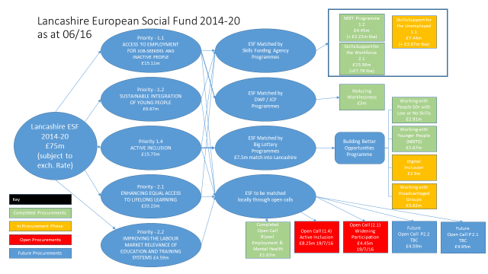

3. City Deal
3.1 A workshop was held on Thursday 5th May with the City Deal Skills and Employment Steering Group members to discuss and agree metrics for the set of objectives identified in the Ekosgen research. These will feed into the overarching City Deal business plan and will be used to assess progress on a quarterly process. The objectives and draft metrics will be presented at the meeting before progressing to the City Deal Executive and Stewardship Board at the end of August.

3.2 A City Deal stand was sponsored at the UCLan Science Fair. The fair took place over a 3 day period in Preston, from Thursday 30th June to Saturday 2nd July. A partnership of 11 organisations came together through the City Deal Information, Advice and Guidance (IAG) Task Force to develop the stand, activities and facilitate engagement over the 3 day period. A Lego bridge building activity was designed with STEMfirst which enabled young people to have a go at designing the proposed new bridge over the River Ribble. It is estimated that over 660 young people, 175 adults and around 70 schools took part in the City Deal stand's activities. Schools requested that the bridge building exercise be developed into a kit for schools with a lesson plan. A summary paper is provided in Appendix B, and a selection of photos from twitter - @LancsSkillsHub.

4. Lancashire HR Forum

4.1 A presentation was delivered at the Community and Business Partnership (CBP) Lancashire HR Employer's Forum, which is supported by Forbes Solicitors and chaired by Joanne Pickering. The forum was attended by approximately 94 businesses. The presentation covered the framework and detailed how employers could get involved in activity – from supporting CEIAG, to engaging with apprenticeships to maximising support from ESF activity. A template was also circulated for employers to complete to help gather intelligence for the soon to be launched SFA project, providing upskilling in the workplace. This intelligence will help to provide a launch pad for the project, once the procurement exercise has been completed.

4.2 As a result of the input, CBP have suggested dedicating the Lancashire Business Growth Forum in February 2017 to skills and employment, which will provide a further opportunity to engage with employers to raise awareness and engage businesses in activity.

5. Growth Deal Skills Capital

5.1 Further to the up-date at the last meeting on the projects that were successful under round 2, the Growth Deal Programme Team are working closely with applicants to progress the Grant Funding Agreements (GFAs). Of the 9 projects approved in April, 4 have now got signed Grant Funding Agreements and are live (Myerscough College – Food and Farming Innovation, Technology Centre, Runshaw College – Enhancing IT Infrastructure, University of Cumbria - Lancaster Campus Teaching Hub and Edge Hill University - Technology Hub). The remaining 5 are being progressed.

5.2 A press release was issued earlier in the month highlighting the second round of allocations and featured in a number of publications. For example, see: http://www.lancashirebusinessview.co.uk/69868-69868/ . Amanda Melton also featured in the LEP newsletter, as Chair of the Skills and Employment Board.

Appendix A: Lancashire Enterprise Partnership priorities for Mentoring
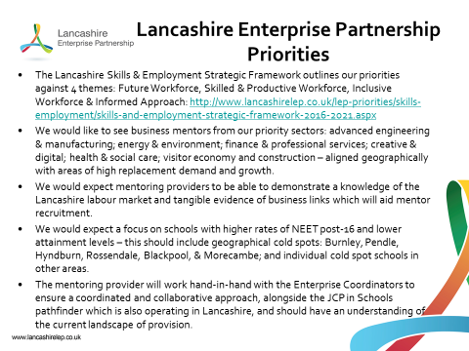

Appendix B
Lancashire Science Festival (30th June – 2nd July 2016)
City Deal Stand

Report Author: Lisa Moizer, Co-ordinator of the Lancashire Skills Hub, lisa.moizer@lancashire.gov.uk
- Background information

  - The Lancashire Science Festival is a three day event (day 1 and 2 for schools, day 3 open to the public) which combines hands-on science learning, with excitement and fun, and brings professional science communicators, theatre shows and more to the region, with the intention of celebrating Lancashire as a hub of science and engineering. In 2015 it had over 11,000 visitors. Sponsorship allows the festival to be free event for schools and families.

  - Jo Heaton, Head of Communications and Engagement at UCLAN, is a member of the City Deal CEIAG Taskforce. Jo brought the opportunity to sponsor a stand at the 2016 UCLAN Lancashire Science Festival to the Taskforce.

  - A proposal was taken to LCC and City Deal that outlined that the Taskforce would take a partnership approach regarding the creating and running the stand, to inform and inspire people about the City Deal and the career opportunities coming out of the City Deal. This approach was successful in securing sponsorship.

2. City Deal Stand

2.1 Sponsorship gave the City Deal stand prime position in the sports hall, the City Deal logo was on the t-shirts and it was given a double page spread in the festival literature.

2.2 The partnership consisted of 11 organisations plus the Lancashire Skills Hub, each donating their time and resources to create the stand. Please see table below for the full list of organisations and their contribution.

2.3 The partnership developed the stand with two activities. In the first activity the young people, designed, costed and then built a bridge with limited Lego pieces. They then went on to build the bridge as quickly as they could. We had a Top Gear style board and they were ranked firstly on cost and then on speed. The bridges spanned from one table to the other, over the 'River Ribble' and on the tables there were mapsof North and South Preston designed in the City Deal marketing style.

2.4 The second activity was a short Buzz Quiz on IPads which asked young people several questions giving them an insight into the type of person they are and the strengths they have. We then took the opportunity to relate that to construction and engineering jobs where appropriate. Alongside this they could look through the prop box and dress up in a variety of protective clothing and pose with various construction/engineering props.

2.5 If the young people engaged in an activity on the City Deal stand they would wear a yellow plastic kid's sized safety helmet which they then kept.

Partner | Contribution
City Deal Communications Team | Supplied the City Deal stand and designed the advert and maps.
Costain | Supplied the traffic lights, cones and safety barriers
Cumbria and Lancashire Network for Collaborative Outreach | Brought the Buzz Quiz activity and prop box and helped run the stand
Eric Wright | Sponsored the safety helmets and hi-vis vests for the young people
Inspira | Helped run the stand
JTL Training | Helped run the stand
National Careers Service | Helped run the stand
Preston Vocational Centre | Supplied the props and helped run the stand
Runshaw College | Helped run the stand
South Ribble Council | Organised Costain and Eric Wright involvement and helped run the stand
STEM First | Commissioned to design the Bridge Building game, organised for two STEM ambassadors to help run the stand

3. Outcomes
3.1 This year's festival saw more than 13,000 visitors over the 3 days of the festival. The City Deal stand was very popular with both the schools and families. It is estimated that over 660 young people, 175 adults and around 70 schools took part in the City Deal stand's activities.

3.2 The activities worked well to attract a wide diversity of young people and allowed us to easily engage young people in conversations about construction and engineering. The safety helmets proved incredibly popular!

3.3 You can see photos on Twitter @LancsSkillsHub and here at http://www.lancashiresciencefestival.co.uk/

3.4 A number of teachers asked about the bridge building game and if it can be brought into schools and the CEIAG Taskforce will look at this and other ways of taking the good practise from the Science Festival forward.

3.5 SKV are creating a media story regarding the City Deal stand which can be used by all partners and will be shared widely.
The Lancashire Skills & Employment Hub would like to say a huge thank you to all the partners involved in the City Deal stand, it was fantastic to be a part of such a positive collaborative effort.

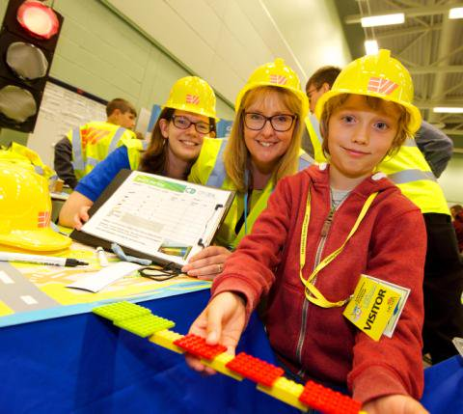 | 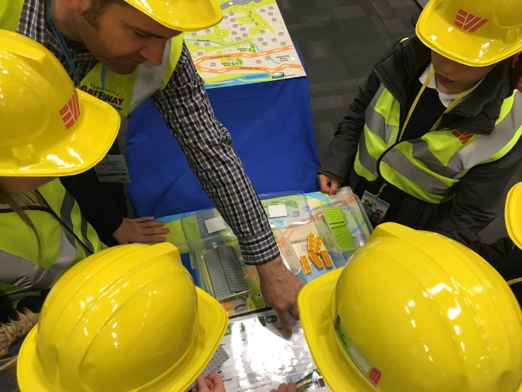
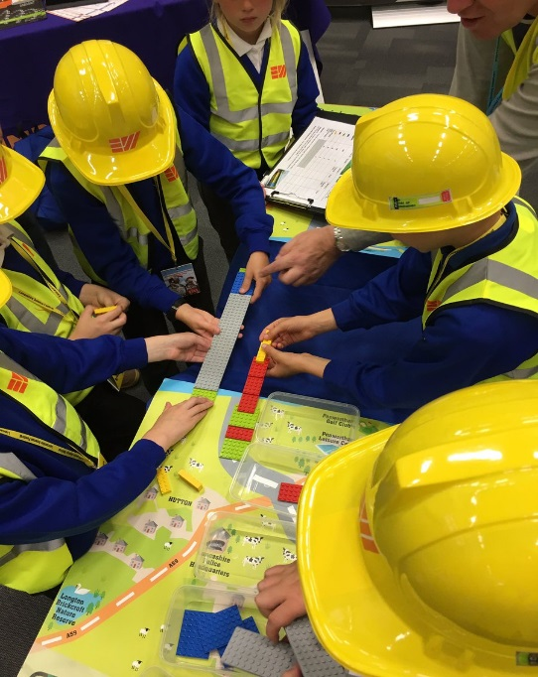 | 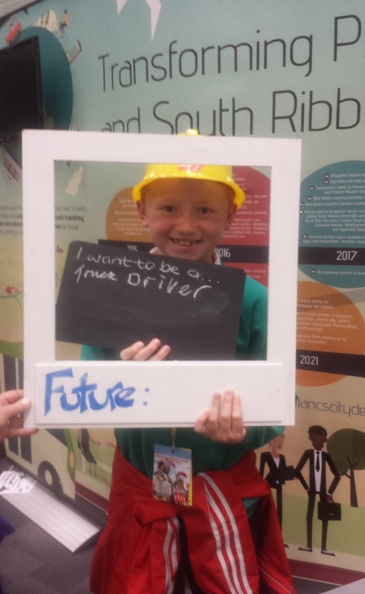
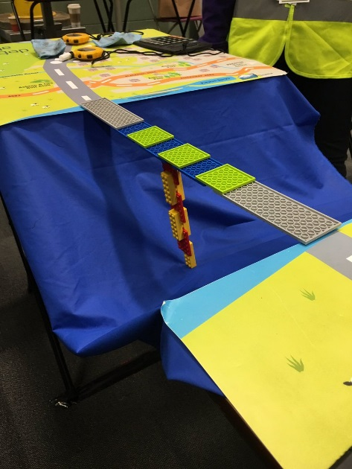 | 